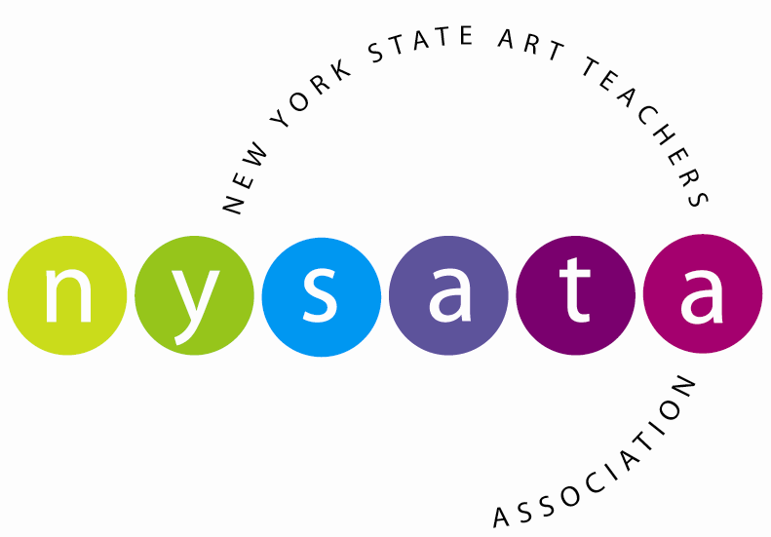

Executive Officers
President
Valerie Savage
Past President
Sharon Ciccone
Vice President
Donnalynn Shuster
Secretary
Anastasia Arriaga
Treasurer
Christine Attlesey-Steger

Region Representatives
Region 1
Veronica Kruger
Michelle Schroeder
Region 2
Alyssa Lindstrom
Janice Wiggins
Region 3
Heather McCutcheon
Kristie Boisen
Region 4
Kathleen Pfeifer
Jill Karen Accordino
Region 5
Shannon Piché-Smith
Alyssa Manning
Region 6
Phyllis Brown
Kathleen Bushek
Region 7
Martin Merchant
Monica Schor
Region 8
Jill Cannon
Pearl Lau
Region 9
Jessica Bayer
Kelly Verdi
Region 10
Cheryl Schweider
Dina Rose

Accounts Receivable
Membership
Conf. Registrar
Terri Konu
Financial Advisor
Leslie Midgley

NYSATA News
Martin Merchant
Alyssa Lindstrom

Web Site/Communications
Cindy Henry

Annual Conference Coordinator
Cynthia Wells
www.nysata.org

September 1, 2019

Dear School Administrator,

We are pleased to announce the 71st annual New York State Art Teachers Association conference will be held at The Double Tree by Hilton, Binghamton, New York, November 22–24, 2019. The annual conference draws over 600 professionals representing K-12 art educators, higher education art educators, museum educators, and commercial vendors. It provides the largest and most diverse professional development opportunities available to New York State art educators.

This year’s conference, Media, Mind, Method: Embracing Change will explore the powerful role art education plays in developing the full potential of all students. Art making pulls together ideas from many disciplines; transforms them into new ideas through multi-layered approaches and processes. The current research in learning and brain development continues to emphasize creative thinking, critical thinking and self-discipline to work in both collaborative and independent settings. These skills are deeply embedded in the teaching and making of art.

Conference opportunities include four general sessions over ninety workshops, that provide interactive learning through hands-on engagement and introduce the most current technologies, art curriculum and standards, assessments, and advocacy materials available. All program events focus on high quality art education content that can be applied immediately to teaching and learning. This year’s general session keynote speakers include art educators and authors Dr. Donalyn Heise and Adrienne Hunter (Art for Children Experiencing Psychological Trauma); acclaimed artist and illustrator Frank Morrison; artist, educator and organizer of community based public art initiatives Joel Bergner; and art educator and artist Beth Atkinson.

In this era of high stakes testing, we know the arts are critically important in developing human potential in our students. I ask your encouragement and support for your art educators in advancing their knowledge and professional skills, by providing release time for their participation and support for conference registration, travel and lodging.

Further information about Media, Mind, Method: Embracing Change and other programs are available at www.nysata.org/2019-confereence.

NYSATA looks forward to providing your art educators a valuable and timely professional experience.

Thank you for your leadership as we work toward ensuring a total quality education for all students.

Sincerely,
Valerie Savage
President, New York State Art Teachers Association

